EC-467 Mobile Application Development

BS (CE)-2021 LAB REPORT #5
Submitted By:

Reg. No. | Name
21-CE-009 | Huzaifa Shahbaz

Department of Computer Engineering
HITEC University Taxila
 | Presentation  (Format(0.5)+  Title (0.5)+  Conclusion(1)  +Procedure(2)  +Objective(1)) | Calculation/ Coding | Observation/  Program Results | Total
Total | 5 | 5 | 5 | 15
Obtained

Lab Instructor.
Dr. Muhammad Bilal

LAB REPORT #5
List View and Array Adapter

Introduction:
Android ListView is a view which groups several items and display them in vertical scrollable list. The list items are automatically inserted to the list using an Adapter that pulls content from a source such as an array or database. Android provides several subclasses of Adapter that are useful for retrieving different kinds of data and building views for an AdapterView ( i.e. ListView or GridView). The common adapters are • ArrayAdapter • BaseAdapter
We can use this adapter when your data source is an array By default, ArrayAdapter creates a view for each array item by calling toString() on each item and placing the contents in a TextView. Consider you have an array of strings you want to display in a ListView, initialize a new ArrayAdapter using a constructor to specify the layout for each string and the string array.
ArrayAdapter adapter = new ArrayAdapter(this, R.layout.history_item_layout, countryArray);

Class Task:
Country List by using List View and Array Adapter.
XML CODE OF MAIN ACTIVITY:
<?xml version="1.0" encoding="utf-8"?>
<LinearLayout
xmlns:android="http://schemas.android.com/apk/res/android"
xmlns:app="http://schemas.android.com/apk/res-auto"
xmlns:tools="http://schemas.android.com/tools"
android:layout_width="match_parent"
android:layout_height="match_parent"
android:orientation="vertical">
<TextView
android:id="@+id/list_tv"
android:layout_width="match_parent"
android:layout_height="wrap_content"
android:text="Country List" />
<ListView
android:id="@+id/country_list"
android:layout_height="match_parent"
android:layout_width="match_parent">
</ListView>
</LinearLayout>

JAVA CODE OF MAIN ACTIVITY:
package com.example.madlab5;
import androidx.appcompat.app.AppCompatActivity;
import android.os.Bundle;
import android.widget.ArrayAdapter;
import android.widget.ListView;
import java.util.ArrayList;
public class MainActivity extends AppCompatActivity {
@Override
protected void onCreate(Bundle savedInstanceState) {
super.onCreate(savedInstanceState);
setContentView(R.layout.activity_main);
ListView countryList=findViewById(R.id.country_list);
ArrayList<String>countryArray=new ArrayList<String>();
countryArray.add("Pakistan");
countryArray.add("Saudi Arabia");
countryArray.add("China");
ArrayAdapter adapter=new ArrayAdapter(this,
R.layout.activity_main,countryArray);
countryList.setAdapter(adapter);
}
}
Results:
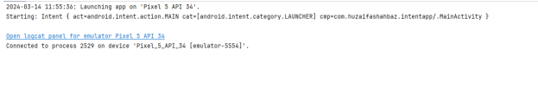
OUTPUT:
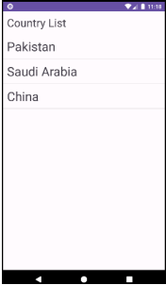

Home Task:
Consider your assignment # 1 and implement the same task using list view on history activity and use array list to add count in main activity and pass this array list to history activity.
Hint: ArrayList historyAL = getIntent().getStringArrayListExtra(TasbeeActivity.MAIN_TO_HISTORY_STRING_KEY)

XML CODE OF MAIN ACTIVITY:
<?xml version="1.0" encoding="utf-8"?>
<LinearLayout xmlns:android="http://schemas.android.com/apk/res/android"
xmlns:app="http://schemas.android.com/apk/res-auto"
xmlns:tools="http://schemas.android.com/tools"
android:layout_width="match_parent"
android:layout_height_="match_parent"
android:gravity="center"
android:orientation="vertical"
tools:context=".MainActivity">
<TextView
android:id="@+id/textView"
android:layout_width="131dp"
</ android:layout_height="wrap_content"
android:text="TextView"
android:textColorLink="#805F5F"
tools:layout_editor_absoluteX="267dp"
tools:layout_editor_absoluteY="142dp" />
<LinearLayout
android:layout_width="match_parent"
android:layout_height="wrap_content"
android:orientation="horizontal">
<Button
android:id="@+id/btn_count_1"
android:layout_width="245dp"
android:layout_height="wrap_content"
android:onClick="onPressCountBtn"
android:text="Count"
tools:layout_editor_absoluteX="198dp"
tools:layout_editor_absoluteY="156dp" />
<Button
android:id="@+id/btn_Rest_1"
android:layout_width="142dp"
android:layout_height="wrap_content"
android:onClick="onPressResetBtn"
android:text="Reset"
tools:layout_editor_absoluteX="247dp"
tools:layout_editor_absoluteY="224dp" />
</LinearLayout>
<Button
android:id="@+id/btnViewhistory"
android:layout_width="match_parent"
android:layout_height="wrap_content"
android:onClick="onPressHistorybtn"
android:text="View history"
tools:layout_editor_absoluteX="296dp"
tools:layout_editor_absoluteY="153dp" />
</LinearLayout>
JAVA CODE OF MAIN ACTIVITY:
package com.huzaifashahbaz.mytasbeehapp1;
import android.os.Bundle;
import android.os.PersistableBundle;
import android.widget.Button;
import android.widget.TextView;
import android.widget.Toast;
import androidx.activity.EdgeToEdge;
import androidx.annotation.Nullable;
import androidx.appcompat.app.AppCompatActivity;
import androidx.core.graphics.Insets;
import androidx.core.view.ViewCompat;
import androidx.core.view.WindowInsetsCompat;
public class MainActivity extends AppCompatActivity {
TextView tvCount;
Button btnCount,btnReset,btnViewHistory;
int count=0;
@Override
protected void onCreate(Bundle savedInstanceState) {
super.onCreate( savedInstanceState );
setContentView( R.layout.activity_main );
tvCount=findViewById(R.id.textView);
}
public void onPressResetBtn(View View){
count=0;
tvCount.setText("Count:"+count);
}
public void onPressHistorybtn(View view){
Toast.makeText( this, "JAZAKALLAJKHAIR", Toast.LENGTH_SHORT ).show();
}
public void onPressCountBtn(View View){
count++;
tvCount.setText("Count:"+count);
}
}

Results:
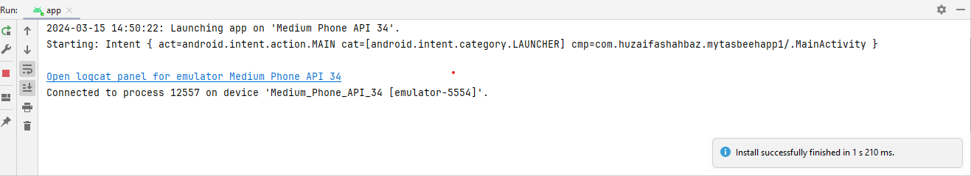

OUTPUT:
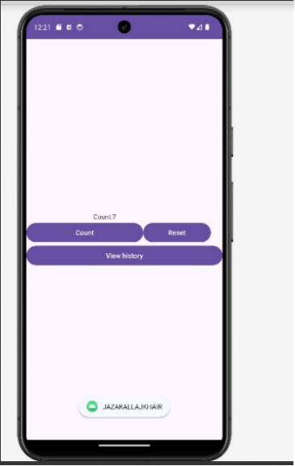

XML CODE OF HISTORY ACTIVITY:
<?xml version="1.0" encoding="utf-8"?>
<LinearLayout xmlns:android="http://schemas.android.com/apk/res/android"
xmlns:app="http://schemas.android.com/apk/res-auto"
xmlns:tools="http://schemas.android.com/tools"
android:layout_width="match_parent"
android:layout_height="match_parent"
android:gravity="center"
android:orientation="vertical"
tools:context=".MainActivity">
<TextView
android:id="@+id/textView"
android:layout_width="131dp"
android:layout_height="wrap_content"
android:text="TextView"
android:textColorLink="#805F5F"
tools:layout_editor_absoluteX="267dp"
tools:layout_editor_absoluteY="142dp" />
<LinearLayout
android:layout_width="match_parent"
android:layout_height="wrap_content"
android:orientation="horizontal">
<Button
android:id="@+id/btnViewhistory"
android:layout_width="match_parent"
android:layout_height="wrap_content"
android:onClick="onPressHistorybtn"
android:text="View history"
tools:layout_editor_absoluteX="296dp"
tools:layout_editor_absoluteY="153dp" />
</LinearLayout>
<Button
android:id="@+id/btnIncrement"
android:layout_width="match_parent"
android:layout_height="wrap_content"
android:onClick="onPressIncrementbtn"
android:text="Increment"
tools:layout_editor_absoluteX="296dp"
tools:layout_editor_absoluteY="153dp" />
</LinearLayout>
JAVA CODE OF ACTIVITY HISTORY:
package com.huzaifashahbaz.assginmentoftabseehcounter;
import android.os.Bundle;
import android.view.View;
import android.widget.Button;
import android.widget.TextView;
import androidx.activity.EdgeToEdge;
import androidx.appcompat.app.AppCompatActivity;
import androidx.core.graphics.Insets;
import androidx.core.view.ViewCompat;
import androidx.core.view.WindowInsetsCompat;
public class historyActivity extends AppCompatActivity {
TextView tvCount;
Button btnIncrement,btnViewHistory;
int count=0;
@Override
protected void onCreate(Bundle savedInstanceState) {
super.onCreate( savedInstanceState );
EdgeToEdge.enable( this );
setContentView( R.layout.activity_history );
tvCount=findViewById( R.id.textView );
}
void onPressHistorybtn(View view){
count=0;
tvCount.setText( "Count:"+count );
}
void onPressIncrementbtn(View view){
count++;
tvCount.setText("Count:"+count);
}
}
RESULTS: 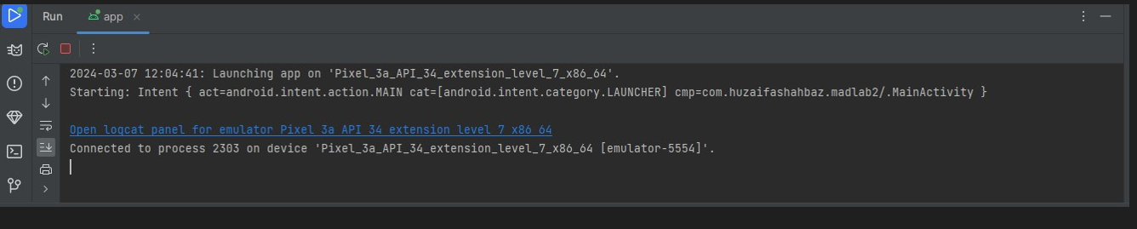
OUTPUT: 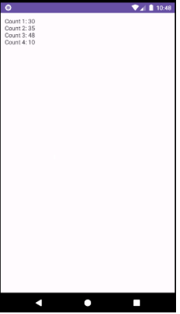

XML CODE OF TASBEEHARRAY ACTIVITY:

<?xml version="1.0" encoding="utf-8"?>
<LinearLayout xmlns:android="http://schemas.android.com/apk/res/android"
xmlns:app="http://schemas.android.com/apk/res-auto"
xmlns:tools="http://schemas.android.com/tools"
android:layout_width="match_parent"
android:layout_height="match_parent"
android:gravity="center"
android:orientation="vertical"
tools:context=". TASBEEHARRAY Activity">
<TextView
android:id="@+id/historytext"
android:layout_width="match_parent"
android:layout_height="match_parent"
android:text=""
android:textSize="20sp"
android:textStyle="bold"
android:fontFamily="causal"/>
<LinearLayout
android:layout_width="match_parent"
android:layout_height="wrap_content"
android:orientation="horizontal">
</LinearLayout>
JAVA CODE OF TASBEEHARRAY ACTIVITY:
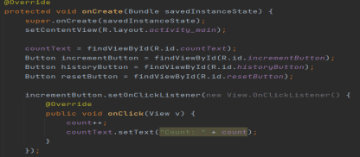

package com.huzaifashahbaz.assginmentoftabseehcounter;
import android.os.Bundle;
import android.view.View;
import android.widget.Button;
import android.widget.TextView;
import androidx.activity.EdgeToEdge;
import androidx.appcompat.app.AppCompatActivity;
import androidx.core.graphics.Insets;
import androidx.core.view.ViewCompat;
import androidx.core.view.WindowInsetsCompat;
public class TASBEEHARRAYActivity extends AppCompatActivity {
TextView tvCount;
Button btnIncrement,btnViewHistory;
int count=0;
@Override
protected void onCreate(Bundle savedInstanceState) {
super.onCreate( savedInstanceState );
setContentView( R.layout.activity_tasbeeharray );
countText=findbyViewById(R.id.countText);
Button incrementButton=findbyViewById(R.id. incrementButton);
Button historyButton=findbyViewById(R.id. historyButton);
Button resetButton=findbyViewById(R.id. resetButton);
incrementButton.setOnClickListener(new View.OneClickListener())
{
@Override
public void onClick(View v)
{
count++;
CountText.setText("Count:"+count);
}
});
historyButton.setOnClickListener(new View.OneClickListener())
{
@Override
public void onClick(View v)
{
Intent intent=newIntent(tasbeeharrayactivity,this,historyactivity.class);
Intent.putIntegerArrayListExtra("Counthistory", historyactivity);
StartActivity(intent);
}
});
resetButton.setOnClickListener(new View.OneClickListener())
{
@Override
public void onClick(View v)
{
CountHistory.add(count);
Count=0;
countText.setText("Count:0");
}
});

}
void onPressHistorybtn(View view){
count=0;
tvCount.setText( "Count:"+count );
}
void onPressIncrementbtn(View view){
count++;
tvCount.setText("Count:"+count);
}
}
RESULTS:

OUTPUT:
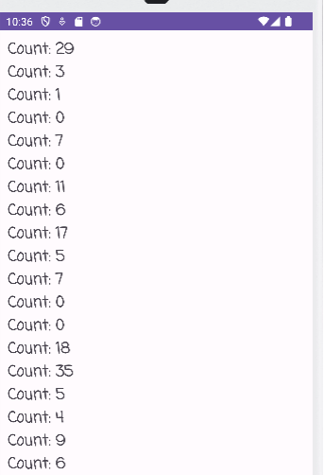

Conclusion:
In conclusion ,we had know about the functions and working of List View and Array Adapter.We also make the tasbeeh counter app by using list view and array adapter in mobile application development by using java code and xml linear layout code.

